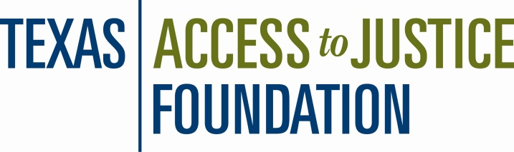

Memorandum

TO: Current & Prospective Texas SLRAP Applicants

FROM: Lisa D. Melton, Special Projects Manager & Payal Vora, Accounting Assistant

SUBJECT: Texas Student Loan Repayment Assistance Program Application

DATE: June 20, 2016

EVERYONE MUST REAPPLY even if you were recently admitted through the Mid-Year Process.

The 2016-2017 application period for the Texas Student Loan Repayment Assistance Program is open until 11:59 PM on March 25, 2016. Since 2008, funding for this program has been made possible due to the generous support of the State Bar of Texas. The purpose of the Texas SLRAP is to encourage and enable recent law school graduates to work for Texas legal aid organizations and to assist legal aid programs in retaining experienced lawyers. Please note that the assistance is structured as a loan, which may be forgiven in the future, rather than a grant.

Attorneys are eligible for loan repayment assistance through this program if they work full-time for any Texas program that is:
- a recipient of Texas Access to Justice Foundation (TAJF) funds,
- a recipient of Legal Services Corporation funds, or
- a Texas non-profit that provides civil legal services if at least 50% of the services provided are free to Texans whose income is 175% of federal poverty guidelines or less.

Additionally, eligibility is limited to applicants who graduated within the last ten (10) years. The date for determining eligibility is the first day of the new SLRAP term, therefore for the 2016-2017 SLRAP year the date is June 1, 2016.

Applicants are charged with knowing the eligibility requirements of the SLRAP. Read the Program Guidelines that accompany the application materials. For complete information on eligibility requirements, please go to the online application site at http://grants.tajf.org.

- If you have not previously done so, register with the site.
- When you receive the e-mail confirming you as a registrant, you can log in at any time. If you are currently registered, use your current log in information. If you do not know it, contact Payal Vora.
- Go to the following funding opportunity: 10073678 -Texas Student Loan Repayment Assistance Program - 2016-2017 Application.
- Review the SLRAP Guidelines and the instructions for each portion of the application carefully.
- Please note: the certifications (law school, employer and lender) MUST be received by this date as well. Securing these will be the most difficult part of the process so don’t delay in making these requests.

Current SLRAP recipients can copy/edit their most recent application into this funding opportunity making the completion process somewhat easier. The editing portion is vital. Please be sure to verify all information to be sure it is correct and up-to-date. Once you have copied an old application, go to General Information within the copied application and select Edit to change project title to include the correct year.

To copy a previous application into this new funding opportunity:
1. Select the Funding Opportunity.
2. Then, select Copy Existing Application.
3. Select the most recent/accurate application from the list.
4. Save it and then update it.

If you have questions about the online site/application process or substantive questions about eligibility contact Lisa Melton, at ldmelton@teajf.org or 512-320-0099 x 330.

